Apache Cassandra’s installing

* Cassandra is NoSql Database management system which is highly durable, Scalability, decentralized and fault tolerant
* Which is interacted with Cassandra Query Language(CQL) similar to SQL syntax
* Cassandra allows peer to peer architecture with no single point of failure.

Prerequisites:

Install java 11 or 17 ,

To use CQL sh install python 3.8 to 3.11.

Installing Method

Docker File,

Tarball Binary file,

Package installation (YUM, RPM).

To install Apache Cassandra on EC2 instance

First need to create a EC2 instance

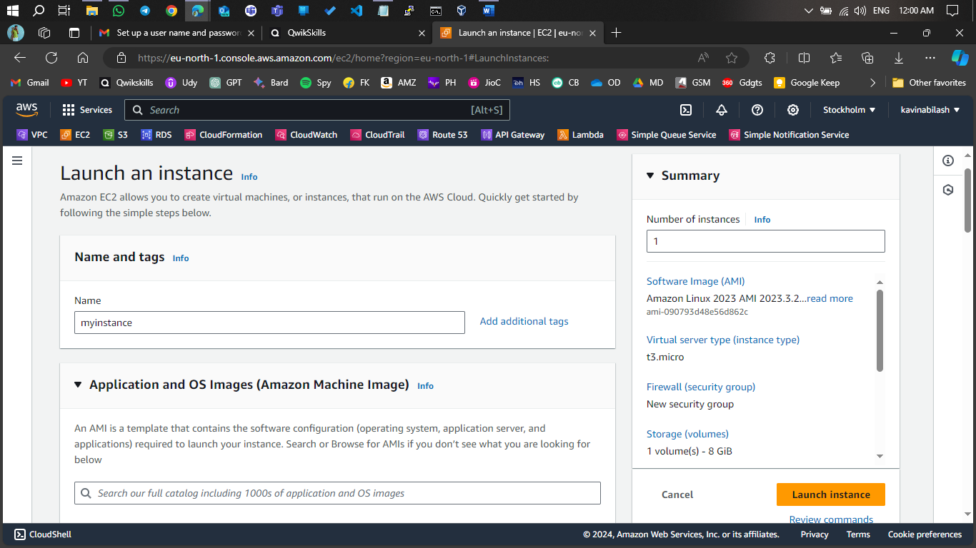

Create keypair to do SSh login

Allow port to access SSH

Once created instance connect with it

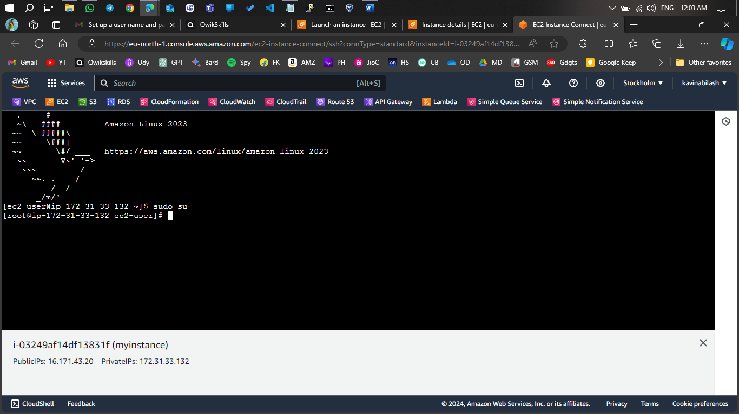

Install Java

Download Cassandra package

Create repo for Cassandra in ETC directory

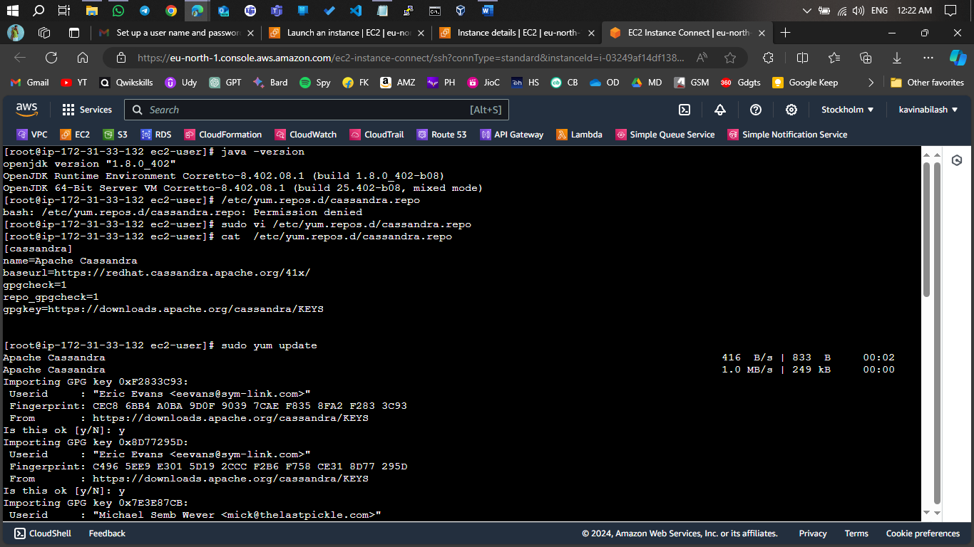

Install Cassandra

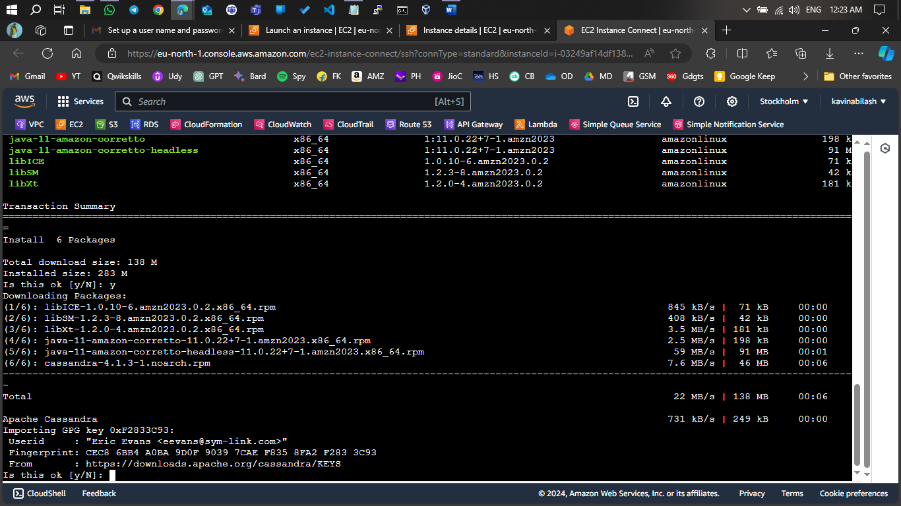

Start Cassandra

